**Practical – 7**

**Introduction to CSS**

1. Create a webpage which displays "Hello World" with font size 20 pixels, bold format, in "Times New Roman" font and green in color using inline CSS, internal/embedded CSS and external CSS.

**HTML Code**

<!DOCTYPE html>

<html lang="en">

<head>

<meta charset="UTF-8" />

<meta name="viewport" content="width=device-width, initial-scale=1.0" />

<title>Css practice</title>

<link rel="stylesheet" href="style.css" />

<style>

.para {

font-size: 20px;

color: rgb(0, 17, 128);

}

</style>

</head>

<body>

<h1>Inline css</h1>

<p style="font-size: 20px; color: rgb(165, 87, 42)">Hello World</p>

<h1>Internal css</h1>

<p class="para">Hello World</p>

<h1>External css</h1>

<p class="para2">Hello World</p>

</body>

</html>

**style.css**

.para2 {

font-size: 30px;

color: red;

}

**Output**

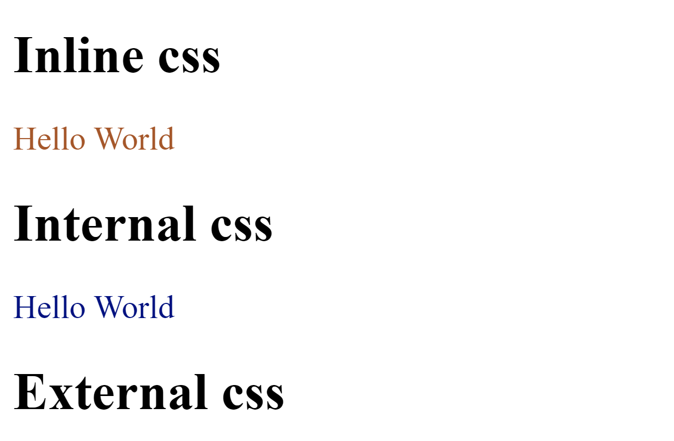

**Practical – 7**

2. Create a webpage which implements CSS for the following appearance.

. For h1 background-color: green

. For p background-color: red

. For div background-color: gray

. For Body set Background image

**HTML Code**

<!DOCTYPE html>

<html lang="en">

<head>

<meta charset="UTF-8" />

<meta name="viewport" content="width=device-width, initial-scale=1.0" />

<title>Practical 2</title>

<style>

h1 {

background-color: green;

}

p {

background-color: red;

}

div {

background-color: gray;

}

body {

background-image: url(img.jpg);

}

</style>

</head>

<body>

<h1>This is H1 tag</h1>

<div>

<h2>this a divition tag</h2>

</div>

<p>

this a paragraph <br />

program number 2

</p>

</body>

</html>

**Output**



**Practical – 7**

3. Create a webpage which implements CSS to set different font type, color and size for H1 to H6.

**HTML Code**

<!DOCTYPE html>

<html lang="en">

<head>

<meta charset="UTF-8" />

<meta name="viewport" content="width=device-width, initial-scale=1.0" />

<title>Document</title>

<style>

h1 {

font-family: "sans-serif";

font-size: 20px;

color: rgb(222, 135, 213);

}

h2 {

font-family: "Tahoma";

font-size: 25px;

color: rgb(0, 255, 60);

}

h3 {

font-family: "Times New Roman";

font-size: 30px;

color: blueviolet;

}

h4 {

font-family: "Arial Narrow Bold";

font-size: 35px;

color: rgb(255, 247, 0);

}

h5 {

font-family: "Cambria";

font-size: 40px;

color: red;

}

h6 {

font-family: "Verdana";

font-size: 45px;

color: rgb(220, 160, 20);

}

</style>

</head>

<body>

<h1>Heading 1</h1>

<h2>Heading 2</h2>

<h3>Heading 3</h3>

<h4>Heading 4</h4>

<h5>Heading 5</h5>

<h6>Heading 6</h6>

</body>

</html>

**Output**

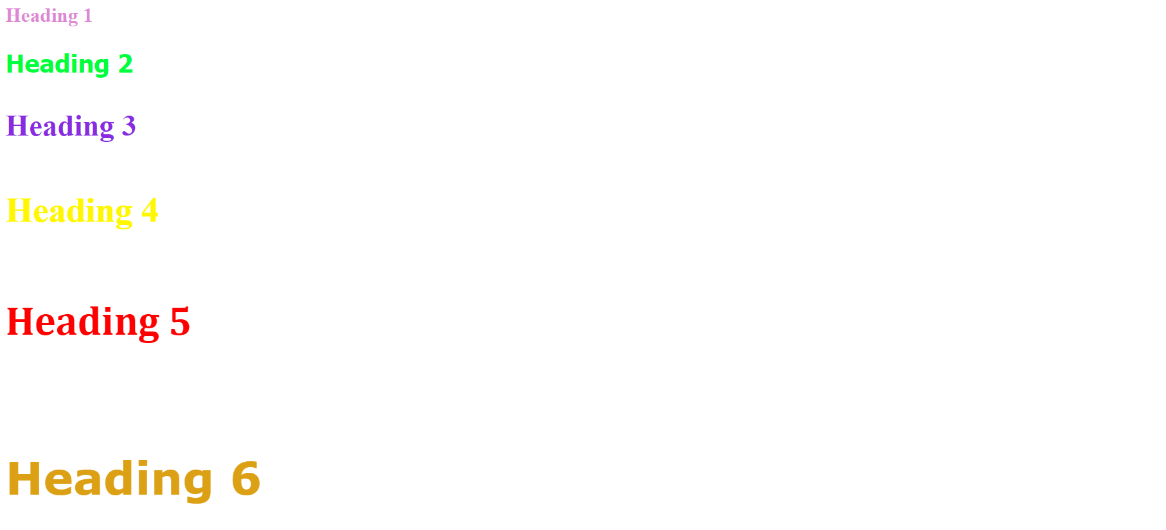

**Practical – 7**

4. Create a webpage which implements different selectors.

**HTML Code**

<!DOCTYPE html>

<html lang="en">

<head>

<meta charset="UTF-8" />

<meta name="viewport" content="width=device-width, initial-scale=1.0" />

<title>selector</title>

<style>

* {

text-align: center;

}

h1 {

color: aqua;

background-color: blueviolet;

}

.p1 {

color: burlywood;

}

#div {

background-color: blue;

height: 500px;

width: 90%;

}

div > p {

color: chartreuse;

font-size: 30px;

}

div h1 {

color: fuchsia;

}

div + h2 {

background-color: aqua;

color: brown;

}

</style>

</head>

<body>

<h1>Heading tag</h1>

<p class="p1">This Is paragraph</p>

<div id="div">

<h1>Hello World</h1>

<h1>Hello World</h1>

<p>this a p tags....</p>

<p>this a p tags....</p>

<p>this a p tags....</p>

</div>

<h2>Hello World</h2>

<h2>Hello World</h2>

<h2>Hello World</h2>

</body>

</html>

**Output**

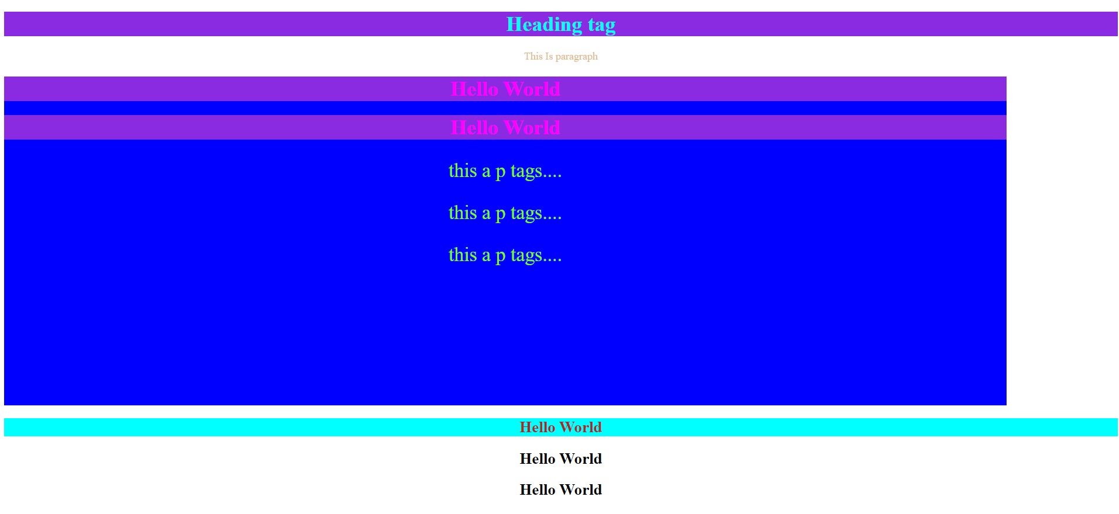

**Practical – 7**

5. Create a webpage which implements different types of borders.

**HTML Code**

<!DOCTYPE html>

<html>

<head>

</head>

<body>

<center>

<h2>The border-style Property</h2>

<p style="border:5px solid black;">Paragraph</p>

<p style="border:5px dotted black;">Paragraph</p>

<p style="border:5px dashed black;">Paragraph</p>

<p style="border:5px double black;">Paragraph</p>

<p style="border:5px groove black;">Paragraph</p>

<p style="border:5px ridge black;">Paragraph</p>

<p style="border:5px inset black;">Paragraph</p>

<p style="border:5px outset black;">Paragraph</p>

</center>

</body>

</html>

**Output**

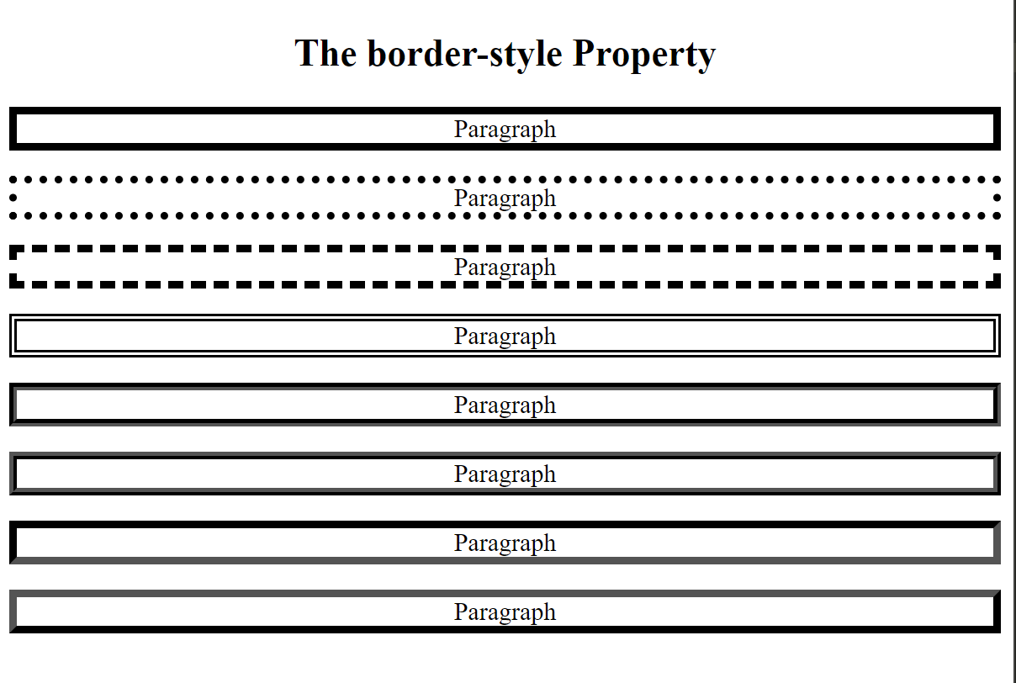

**Practical – 7**

6. Create a webpage which implements different CSS text property.

**HTML Code**

<!DOCTYPE html>

<html lang="en">

<head>

<meta charset="UTF-8" />

<meta name="viewport" content="width=device-width, initial-scale=1.0" />

<title>Document</title>

<style>

p {

text-decoration: dotted;

text-indent: 5%;

text-align: center;

text-transform: capitalize;

white-space: inherit;

word-spacing: 2%;

letter-spacing: 10px;

line-height: 50px;

color: brown;

font-size: 50px;

}

</style>

</head>

<body>

<p>This is a paragraph tag</p>

<p>hello World</p>

</body>

</html>

**Output**



**Practical – 7**

7. Create a webpage which generate zebra stripe table. [Hint: Use the nth-child() selector and add background-color of your choice to all odd (or even) table rows/columns. Apply on tr or td elements]

**HTML Code**

<!DOCTYPE html>

<html lang="en">

<head>

<meta charset="UTF-8" />

<meta name="viewport" content="width=device-width, initial-scale=1.0" />

<title>zebra table</title>

<style>

table {

border-spacing: 0;

width: 100%;

border: 1px solid #000000;

}

tr:nth-child(even) {

background-color: #a6afa9;

}

</style>

</head>

<body>

<table border="2">

<tr align="center">

<td>raman</td>

<td>anup</td>

</tr>

<tr align="center">

<td>dinesh</td>

<td>ramesh</td>

</tr>

<tr align="center">

<td>suresh</td>

<td>om</td>

</tr>

<tr align="center">

<td>ram</td>

<td>nik</td>

</tr>

</table>

</body>

</html>

**Output**

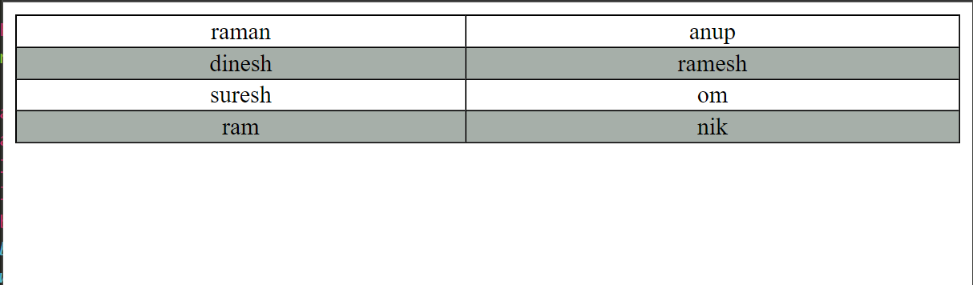

**Practical – 7**

8. Create a webpage which implements following pseudo-classes and pseudo-elements. [

Syntax:

selector: pseudo-class{

property: value;

}

]

**HTML Code**

<!DOCTYPE html>

<html>

<head>

<title>Pseudo-classes & Pseudo-elements</title>

<style>

.first-child {

color: red;

}

.last-child {

color: blue;

}

.only-child {

color: green;

}

.nth-child {

color: orange;

}

.nth-last-child {

color: purple;

}

.hover:hover {

color: yellow;

}

.focus:focus {

color: pink;

}

.active:active {

color: cyan;

}

.visited:visited {

color: magenta;

}

.link:link {

color: lime;

}

::before {

content: "-";

color: black;

}

::after {

content: "--";

color: rgb(224, 88, 88);

}

</style>

</head>

<body>

<h1 class="first-child">First Child</h1>

<p class="last-child">Last Child</p>

<p class="only-child">Only Child</p>

<p class="nth-child">Nth Child</p>

<p class="nth-last-child">Nth Last Child</p>

<p class="hover">Hover</p>

<p class="focus">Focus</p>

<p class="active">Active</p>

<p class="visited">Visited</p>

<p class="link">Link</p>

<p>This is a Paragraph.</p>

</body>

</html>

**Output**

